**EGR-334**

**Analog - Digital Interface**

**Homework 1.0**

**Week 6**

**Thursday September 20, 2018**

**Due Thursday September 27, 2018**

**Please write clearly and neatly, your solution in the space provided, or Attached Additional Calculations. Refer to Supplemental Materials and Data Sheets on Black Board.**

1. **For the Network Shown Below, Determine the Following for an Input of 1 mVpp Signal:**

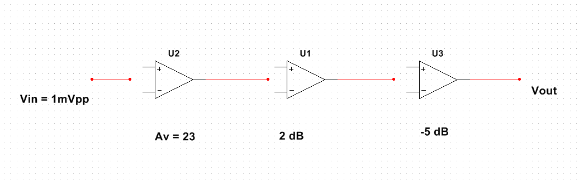

20log(Av) = dB

Avtot = Av1*Av2

dBtot = dB1+dB2

Av=Vout/Vin

dB = 20log(23) = 27.235, dBtot = 27.235+2-5 = 24.235

Avtot = 10^(db/20) = 10^(24.235/20) = 16.284

Vout = Av*Vin = 16.284*1mVpp = 16.284 mVpp

**Overall Gain ___16.284___**

**Overall Gain dB _____24.235 dB____**

**Vout ___16.284 mVpp ___**

1. **For the Network Shown Below, Determine the Input Power Pin for an Output Power Pout of 2.5 W:**

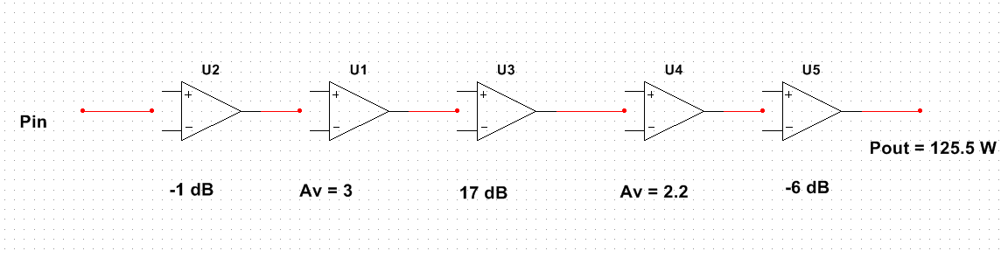

**GaindB = 10log(Av)**

**Ap = Pout/Pin , Ap = Av^2**

dB1 = 10log(3) = 4.771dB; dB4= 10log(2.2) = 3.424dB

dBtot = db1+dB2+dB3+dB4+dB5 = 18.195dB

Aptot = 10^(dBtot/10) = 66

Pin = Pout/Ap = 125.5/66

**Overall Gain ___66___**

**Overall Gain dB ___26.39 Db____**

**Pin __1.9 V__**

1. **For the Inverting Operational Amplifier shown below, Determine the Output Voltage for the Following Conditions:**

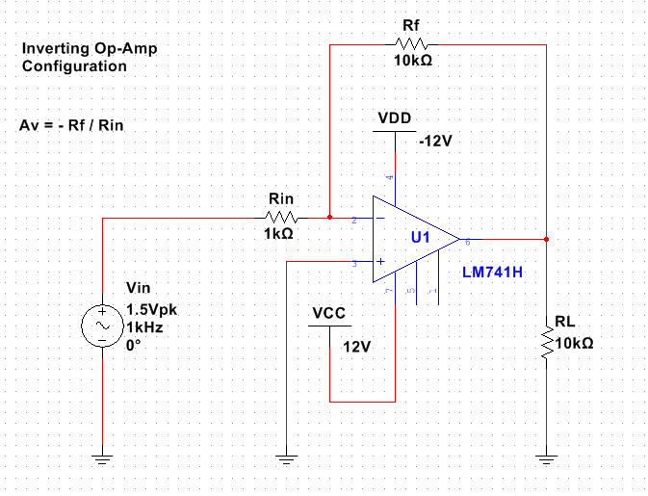

**Output Voltage if Rf Shorted ____0V____**

**Output Voltage if Rf Open _____12V_____**

1. **Design a Logarithmic Operational Amplifier Network that will take the Logarithm of and Input, and Verify Inputs 1, 2, 3, 4, and 5 Against a Handheld Calculator and Network Modeled in Multisim. Attach Multisim Model Screen Shot with Results for Inputs 1, 2, 3, 4, and 5.**

Log(1V) = 0, log(2V) = 0.3V, etc; see MITRES 482

1. 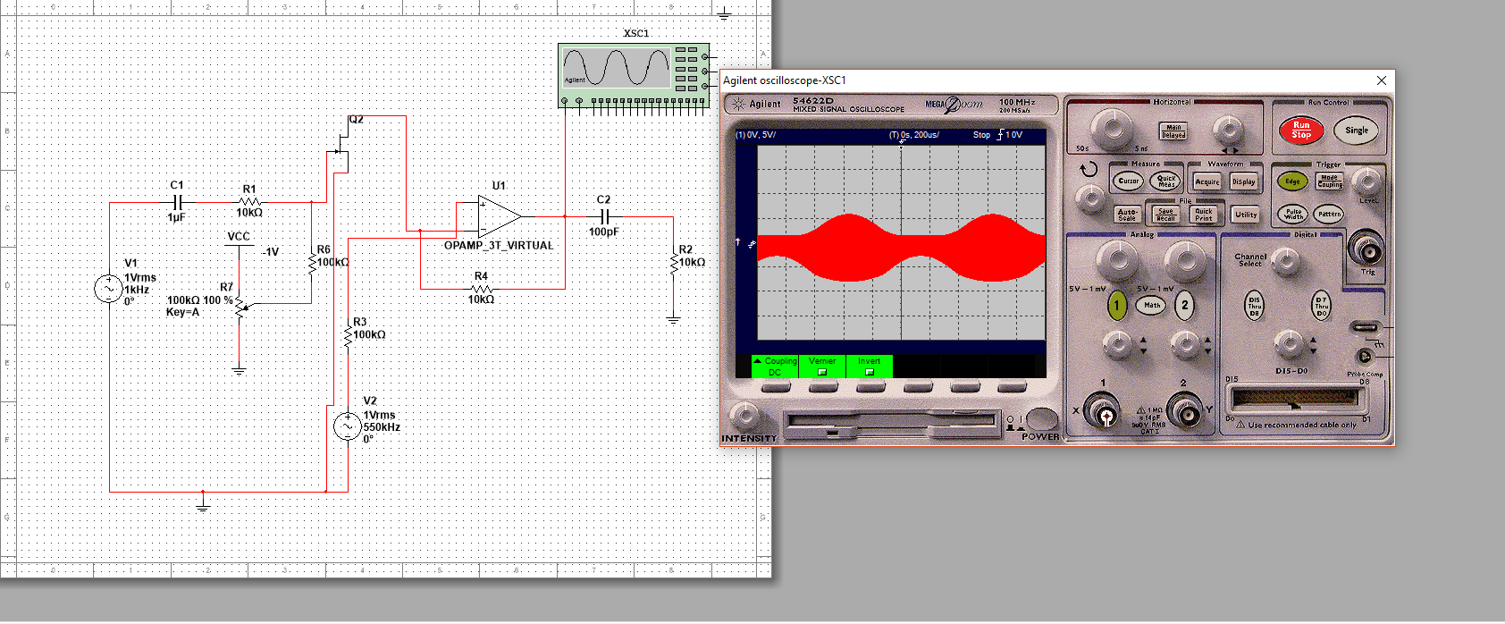**Design and Verify Operation in Multisim a Operational Amplifier AM Modulator Network that will Mix a 550 kHz Carrier Signal with a 1 kHz Information Signal. Attach Multsim Model Screen Shot.**
2. **Design by Hand Through Hand Calculations and Verify Operation in Multisim for an 8th Order BP Chebyshev Filter. The Design will Accommodate a 800 kHz Center Frequency and 10 kHz Bandwidth with 1 dB Allowable Ripple in Pass Band.**

**Attach Multisim Model Screen Shot and Multisim Bode Plot Screen Shot. Include all Hand Calculations and Stated Assumptions.**

**Calculate Filter Q.**

1. **Design by Hand Through Hand Calculations and Verify Operation in Multisim for a Butterworth Band Reject Filter. The Design will Accommodate a 500 kHz Center Frequency and 5 kHz Bandwidth. Filter is to be Down -50 dB at Upper and Lower Cutoff Points.**

**Attach Multisim Model Screen Shot and Multisim Bode Plot Screen Shot. Include all Hand Calculations and Stated Assumptions.**

**Calculate Filter Q.**

1. **Given a AM Amplitude Modulation Signal Driving a 50 Ohm Coax Cable with a Center Frequency of 1 Vpk 10 kHz and 1 kHz Information Signal, 100% mod index, Determine the Following. Provide Verification, Calculations, Bode Plots, and All Other.** 100% modulation index, PEP = Vpp^2/R = Pcarrier+Plsb+Pusb; use voltage across the coax, which I guess is half the input

1/2Ptot = Pcarrier, 1/2Ptot=Plsb+Pusb

**Attach Waveforms screen Shot as Needed. Include all Hand Calculations and Stated Assumptions.**

PEP = Vpp^2/R = (2*0.67 Vpk)^2/50

1/2PEP = Plsb+Pusb

**a) Peak-Envelop Power Expressed in Watts ____0.036 W____**

**b) Side Band Power Expressed in Watts ___0.0090 W___**

1. **For a THS4211 Texas Instruments Low-Distortion, High-Speed, Voltage Feedback Amplifier, Determine the Following:**

**Attach Specific Data Sheet Pages and Supporting Documentation.**

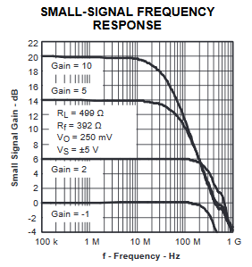

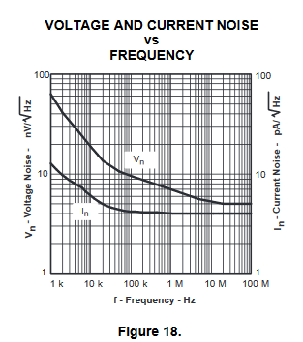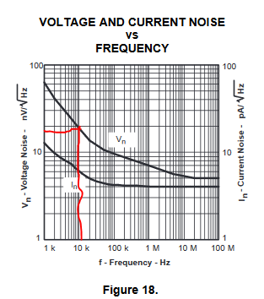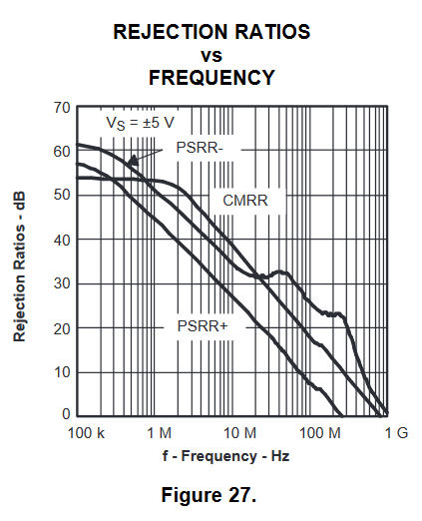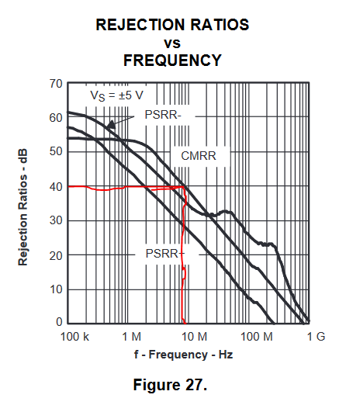

**a) -3 dB Cutoff Frequency Small Signal Response @ Gain = 5 __**900 MHz**__**

**b) Voltage Noise @ 11 kHz nV / SQRT(Hz) __**18 nV / SQRT(Hz) **__**

**c) CMRR Common Mode Rejection Ratio dB @ 8 MHz __**40 dB**__**

1. **From the Sine Waveform shown below, Determine the S/N Ratio.**

S/NdB = 10log(Ps/Pn) = 20log(Vs/Vn)

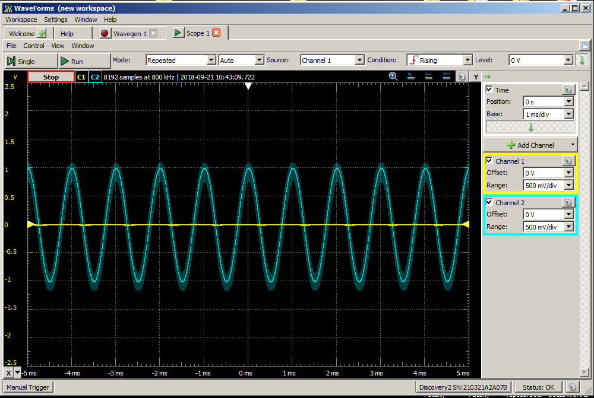

Vrms = Vp/sqrt(2)

SNR = Psignal / Pnoise = (Asignal / Anoise)^2

Vs = 1V; Vn = 0.1V

SNR = 20log(Vs/Vn) = 20log(1/0.1)

**S/N Signal-to-Noise Ratio in dB__20.0 dB__**

1. **For the Instrumentation Amplifier Network shown below, Determine the Following Quantities:**

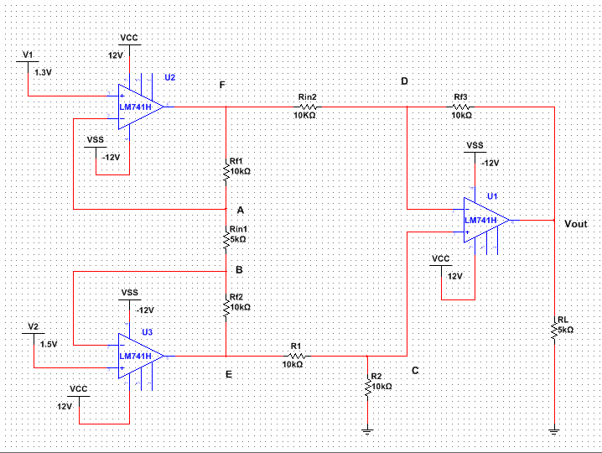

**VRin2 _________**

**IRin2 __________**

**IRf3 ___________**

**VRf3 __________**

**Vout __________**

**VA ____________**

**VB ____________**

**VRin1 __________**

**IRf1 ___________**

**VRf1 ___________**

**IRf2 ___________**

**VRf2 ___________**

**VE _____________**

**VF _____________**

**VC _____________**

**VD _____________**

**PRL ____________**